**DIVOC Prototype Pre-Evaluation Study**

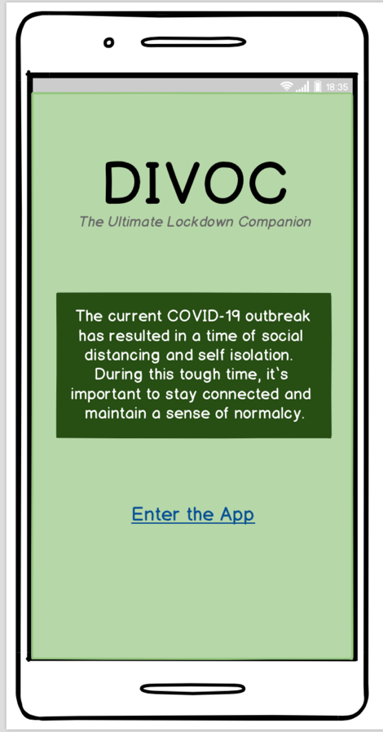

1. In your own words, describe what do you think you can do on this application? Be specific.

- The application looks like it can provide support for anyone to stay in touch with others, as well as get other things be available at the touch of a button. Feels like a social app where a person can communicate as well as get any useful information about the pandemic to stay relevant and sane during these tough times.

1. From your initial understanding of the application, do you know any companies or applications that are similar to this one? If so, explain how this one compares.

- The application seems to be somewhat unique, the only company which I can think of with similar information available through the app off the top of my head is CDC, they have an app which provides updates about the pandemic, but that I do not think let’s you communicate with others so that feature seems to take this app a level above.

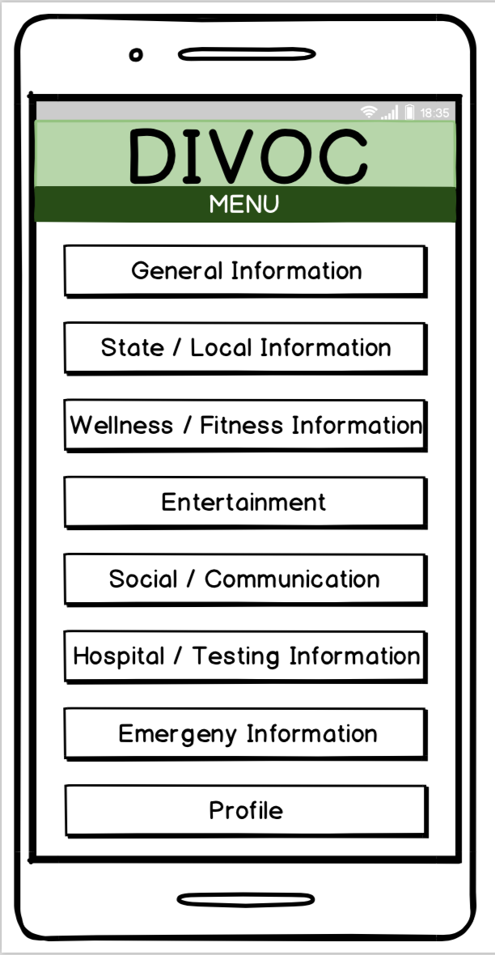

1. On the menu screen, one by one, describe what you think the buttons mean.

General Information: The section looks like it will be about the general information about the pandemic, with information such as currently affected, recovered, and information on how to avoid and maintain social distancing.

State/Local Information: The section looks like it must have information on State level quarantines and lockdowns. Any infomation group gathering and openings of public places.

Wellness/Fitness Information: The section must be about how to stay fit and maintain wellness during this times, with different exercises and other items to help maintain healthy lifestyle.

Entertainment: The section must be about entertainment such as local theatres, cinemas, streaming services etc.

Social/Communication: Section similar to other social media where you can connect with people.

Hospital/Testing Infomation: Section must have information on hospitals and local testing availability.

Emergency Information: Emergency contacts etc

Profile: Personal information and other important details.

1. Without leaving the menu screen, describe what you would select first. **Do not select anything yet.

I would most likely select either the general information or profile menu first.